# Connecting MongoDB to Power BI Desktop

* Download and Install MongoDB ODBC Driver.

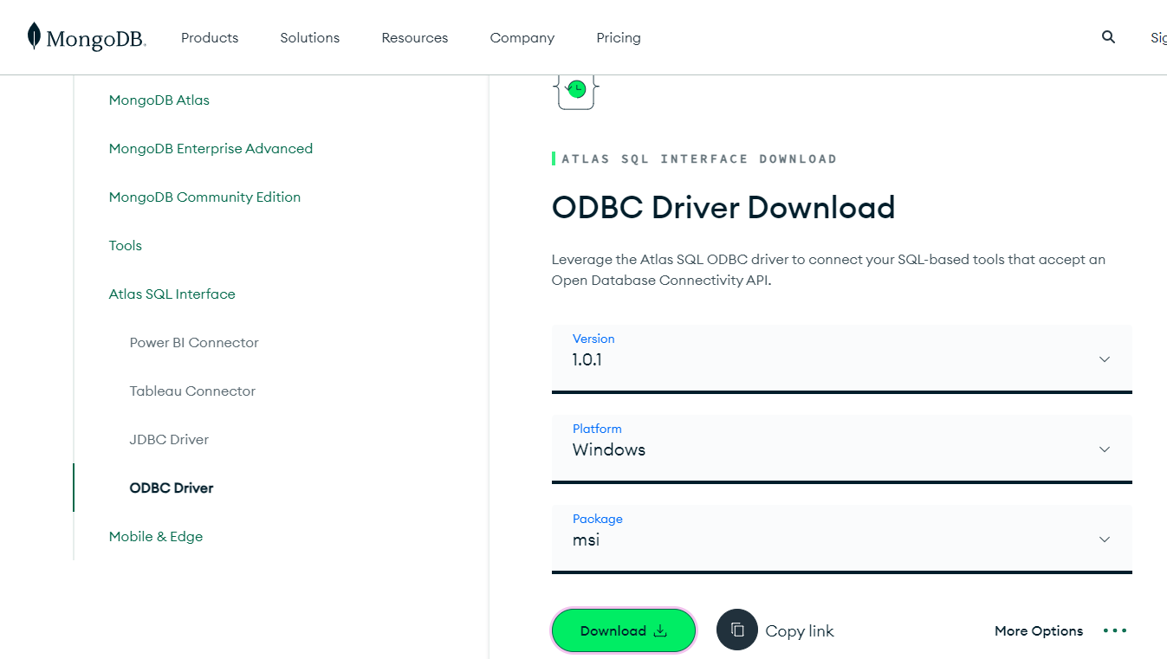

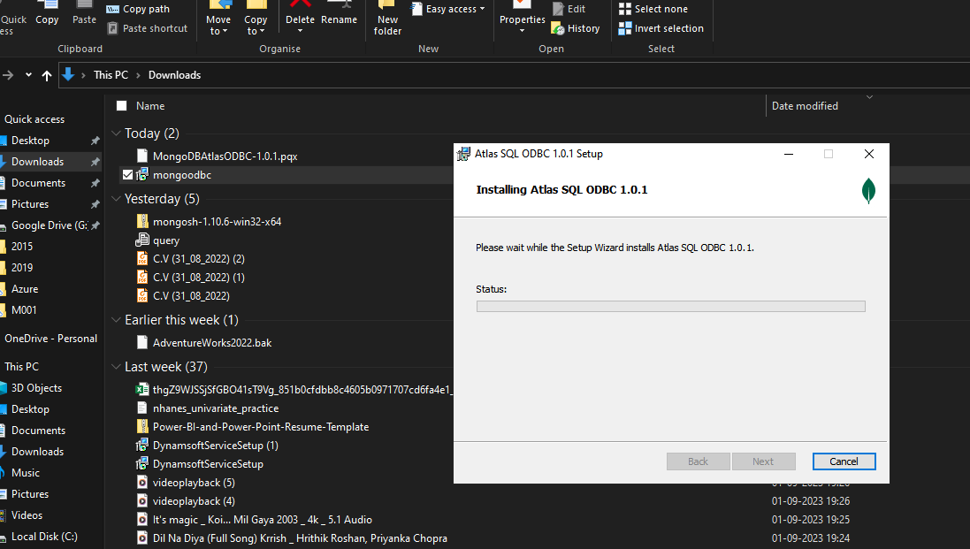

* Download the MongoDB Atlas Power BI Connector.

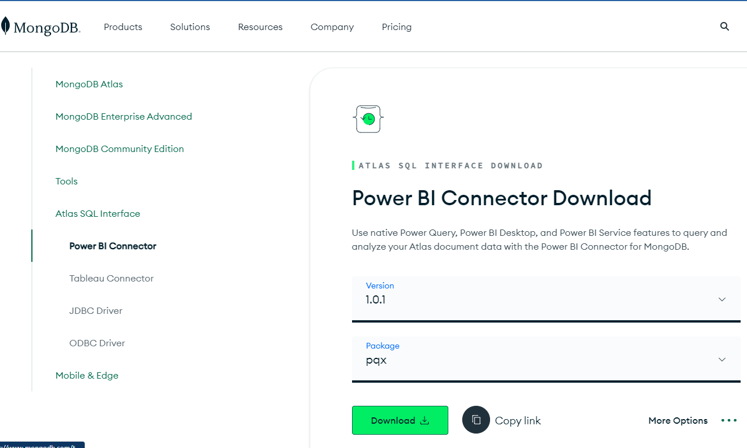

* Move the connector file to the following directory path:

**C:\Users\<user>\Documents\Power BI Desktop\Custom Connectors.**

Create this folder if it doesn't already exist.

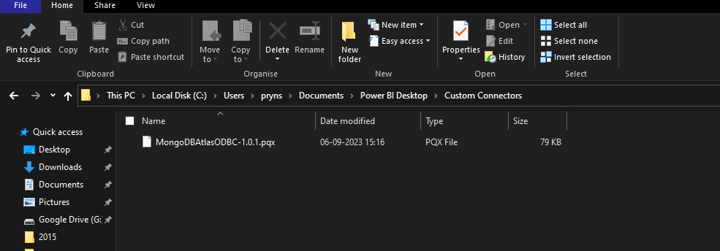

* Copy Database ***uri*** connector
  + Click Database in the left navigation and find the cluster you want to connect.
  + Under Atlas SQL, click Connect.
    - On the lower right side of the cluster card under Atlas SQL, click Connect.
    - If the Introducing the Atlas SQL Interface dialog box displays, click Get Started.
  + Click Quick Start
  + Under Create an Atlas SQL Connection for this cluster, click Create
  + Under Select your driver, select Power BI Connector.
  + Under Get Connection String, select a database and copy the URL.
    - The URL is required to connect from Power BI Desktop.



* Connect to Power BI Desktop
  + Open Power BI Desktop.
  + Select Get data from the Home menu.
  + Find and select the MongoDB Atlas SQL connector.
  + Type mongo in the search bar to find the new connector.
  + Select MongoDB Atlas SQL.
  + Click Connect.
    - Enter the URI and the database name and click OK. (The MongoDB URI is the URL is the from the previous step.)
    - Enter your Atlas User name and Password and click Connect.
  + By default, a user can access all clusters and federated database instances in projects to which they have access. If you restricted access to specific clusters and federated database instances, you can grant access to the new federated database instance in the Edit User menu.

